**Need Greater Income From Your SMSF?**

While the Reserve Bank is saying that the official 2.5% cash rate could be around for some time, you may need to consider strategies that pay better than low-yielding term deposits or cash.

Many people have shares and property in their portfolios. If you own shares then writing (selling) covered call options over the shares you own, should out-perform just holding the shares alone.

“Historically, writing covered call options over shares you own has out performed just owning shares alone.  See <http://www.asx.com.au/documents/resources/buy_write.pdf>”

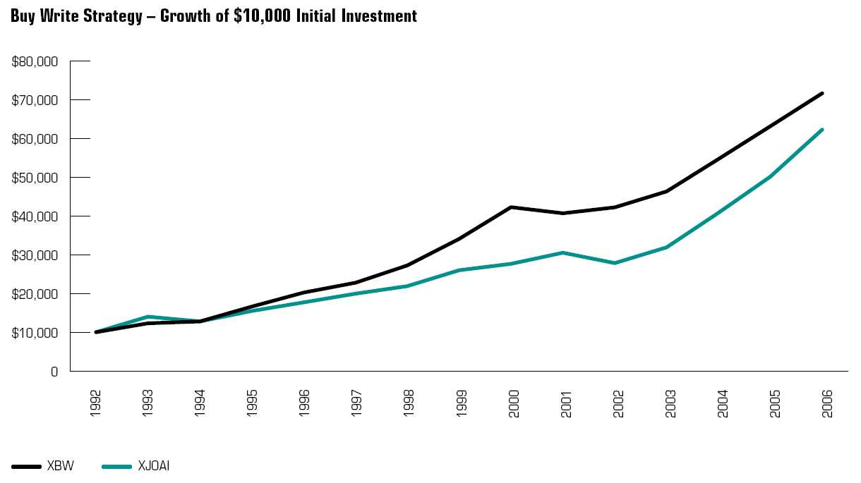

**If you own shares** you can create a report in ProWriter Plus software that will show you the option returns available for each of your stocks, for every month.

This data is presented in simple tabulated form and can be seamlessly imported into a trading plan to show you the returns available for the month, before you even place a trade.

All overheads, including brokerage, associated with trading in a SMSF could be paid for by the fund.

Have a look at the My Covered Calls data service by taking the free trial. Opt out at any time.

If you have any questions our associate Advisor would be happy to speak with you.

Just email [support@mycc.com.au](mailto:support@mycc.com.au) requesting a friendly call. Please include your best contact phone number.

Or, if you would like to know more please email [support@mycc.com.au](mailto:support@mycc.com.au)